### Data description

1. **What the different files are?**

We currently have two different data files that originated from Liu & Jaeger, 2018. One is the collected data from the exposure phase while the other one is from the test phase.

1. **What do the different column names mean?** 
   1. **Exposure csv. File**
      1. Label: The target token contained in the word. S-label means the word contains the token that is normally pronounced as /s/. SH-label means the word contains the token that is normally pronounced as /sh/. Filler- label means the word doesn’t contain /s/ or /sh/.
      2. Condition: If the pronunciation of the token is paired with pen-in-hand/ pen-in-mouth manipulations.
      3. Contains fricative: if the word contains target fricatives. true/false
      4. Contains normal fricative: if the target fricative is pronounced normally. true/false
      5. Contains shifted fricative: if the target fricative is pronounced ambiguously. true/false
      6. Is correct: if the response = right answer. Correct =1/ incorrect =0

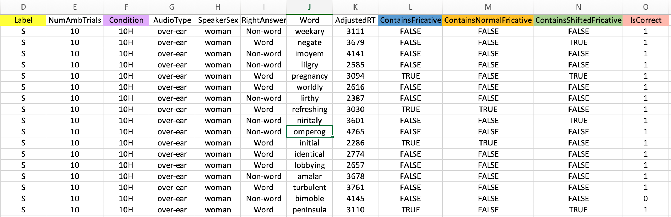

* 1. **Test csv. File** 
     1. Response: Participants’ categorical decision of the target tokens. S/SH
     2. RT: participants’ reaction time of recognizing the category of target tokens
     3. Label: The target token contained in the word. S-label means the word contains the token that is normally pronounced as /s/. SH-label means the word contains the token that is normally pronounced as /sh/. Filler- label means the word doesn’t contain /s/ or /sh/.
     4. Condition: If the pronunciation of the token is paired with pen-in-hand/ pen-in-mouth manipulations.
     5. Step: I’m confused about the data listed under the column since we assume there will just be 6 steps on the /asi/ ~ /ashi/ continuum.
     6. Subject: Confusion. I assume the number listed below means “Group number” associated with each test block. Looking through the data file, each block contains 60 trials.

